**Using Dictionaries**- Can access values in dictionary by calling keys  
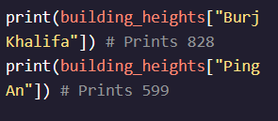

- Can use error checking to determine if a key: value pair is in list before printing and getting an error  
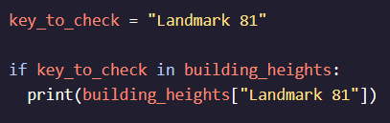 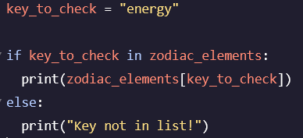

- Can utilize built in *.get()* function to check if key is in list   
- Can specify a value that you want returned if key: value is not in list   
 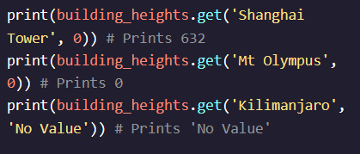

**Deleting Keys:**- Can delete keys from dictionary using *.pop()* and a default value to return if key does not exist  
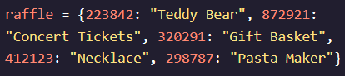 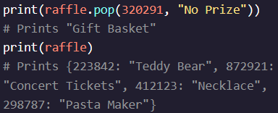  
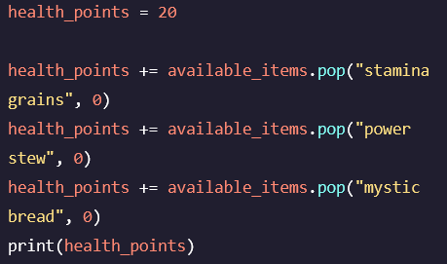

**Get All Keys**- Can get a list of all keys in a dictionary at once using the *.list()* function  
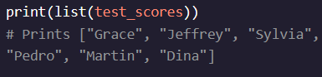

- *dict_keys* return a list of key or values that is view only and cannot be modified  
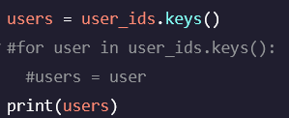 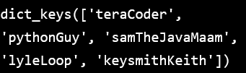

**Get All Values**-Can use a similar function to return all values, *dict_values, .values()*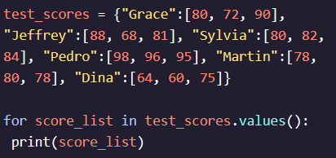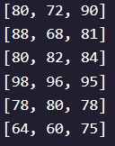

**Get All Items**- Can get all items (keys and values) by using built in *dict_list, .items()* method  
